DO THE CHANGES IN OIL PRICES AFFECT FOOD PRICE?
CASE STUDY IN INDONESIA

Erwin Candra¹⁾ and Rizqi Sari Anggraini²⁾

¹⁾ Mahasiswa Magister Agribisnis Universitas Riau
²⁾ Peneliti Pada Balai Pengkajian Teknologi Pertanian (BPTP) Riau

ABSTRAK

Makalah ini bertujuan untuk mengetahui hubungan antara perubahan harga bahan bakar dengan inflasi pangan di Indonesia. Makalah ini juga menganalisis jenis bahan bakar minyak dan mencoba membandingkan kasus ini di 5 provinsi berbeda di Indonesia. Penelitian ini menggunakan data time series dan panel. Data time series digunakan untuk analisis deskriptif perkembangan laju inflasi di Indonesia. Selanjutnya, data panel digunakan untuk menganalisis berdasarkan provinsi di Indonesia. Sedangkan jangka waktu (t) adalah 34 tahun pada periode 1979-2012 dan jumlah data panel (t) adalah 3 tahun pada periode 2013 - 2015. Penelitian ini menggunakan data sekunder yang berkaitan dengan harga bahan bakar minyak dan inflasi tarif di Indonesia. Analisis dalam penelitian ini menggunakan analisis deskriptif dan metode Ordinary Least Square (OLS) dengan estimasi efek tetap. Hasil penelitian menunjukkan Pengaruh perubahan harga bensin dan solar secara signifikan berkorelasi dengan inflasi di Indonesia. Hal ini dapat dilihat dari R2 0,88, berarti fluktuasi 88% dalam tingkat inflasi ditentukan oleh harga bahan bakar minyak.

Kata Kunci: beras, Inovasi sistem sektoral

ABSTRACT

This paper aims to find out the correlation between a changed of fuel price to food inflation in Indonesia. This paper also try to analyse all kinds of oil fuel and try to comparing the case in 5 difference provinces in Indonesia. This study uses time series and panel data. Time series data are used to the descriptive analysis of inflation rate development in Indonesia. Furthermore, the panel data are used to analyse by province in Indonesia. Whereas, the number time series (t) is 34 years in the period 1979-2012 and the number of panel data (t) is 3 years in the period 2013 – 2015. This study are used secondary data related to oil fuel price and inflation rate in Indonesia. The analysis in this study deploys descriptive analysis and Ordinary Least Square (OLS) method with fixed effect estimation. The result showed The effect of gasoline and diesel price change significantly correlate to inflation in Indonesia. It can be seen from R² 0.88, means 88 % fluctuation in inflation rate are determined by oil-fuel price. However, the model gives the strange result.

Keyword: rice, sectoral system of innovation

INTRODUCTION

Food security exists when all people, at all times, have physical, social and economic access to sufficient, safe and nutritious food that meets their dietary needs and food preferences for an active and healthy life. Household food security is the application of this concept at the family level, with individuals within households as the focus of interest. Food insecurity exists when people do not have adequate physical, social or economic access to food as defined above. (FAO, 2003).
Many recent concerns about food security focus on unpredictable but shorter-lived threats to current food security levels such as price shocks and natural disasters. Unlike chronic food insecurity, transitory food insecurity occurs because of a temporary decline in household access to adequate food. Shocks like droughts or economic downturns can affect individuals who normally have appropriate access to food, threatening the stability of food security which implies adequate access to food at all times. It is particularly relevant for emerging economies that are rapidly reducing poverty and the prevalence of food insecurity, but are still vulnerable to shocks that could bring transitory food insecurity. Developed countries also sometimes raise these concerns when justifying their agricultural policies (OECD, 2015).
Monitoring global and national food price crisis can assist decision makers to better intervene when an eventual food crisis occur in particular region. In general terms, conditions that categorize a region as food crisis are lack of food availability, limited access to food and high prevalence of malnutrition (Cuesta et al (2014).
There is broad consensus that the 2007–2008 food price crisis was detrimental to the welfare of the poor all over the world. For example, in its 2008 State of Food Insecurity publication, the Food and Agriculture Organization of the United Nations (FAO) (2008) estimates that the number of chronically hungry people in 2007 increased by 75 million over its estimate of 848 million undernourished in 2003–2005, with much of the increase attributed to high food prices. Ivanic and Martin (2008), based on averages from their nine-country study, estimate that 105 million people could be thrown into dollar-a-day poverty because of the global food price increases.
In Indonesian food price seems always affected by global oil price. The fluctuation of global oil price affect to economic growth and tend to affect inflation rate. High economic growth has been achieved for 25 years of Indonesian development since 1969. It was triggered by a huge oil export earning, due to high global oil price. In 1970, oil export was 40.3 % and increased in 1982 to become 82.4 %. However, Indonesian economic growth tent to be decline, in line with lower oil export earning, due to the decreased of domestic oil production.
Indonesian government faced problem where provide energy subsidies that resulting in a deteriorating budget deficit or decrease subsidies that resulting the higher inflation rate due to higher domestic oil price. It was caused by 2004, Indonesia turn into a net oil importer as domestic oil output declined sharply while domestic fuel consumption surged amid the growing economy.
Indonesian government regulation to decrease oil subsidies by increase gasoline price IDR.2000/ litre and IDR. 1000/diesel has been predicted will increase the inflation rate. Their reasoning was not only that oil products are required to run agricultural equipment, raising the costs of producing food commodities, and that higher oil prices may raise the price of processing, storing, and distributing food to retail customers (Baumeister and Kilian 2013).
This paper aims to find out the correlation between a changed of fuel price to food inflation in Indonesia. This paper also try to analyse all kinds of oil fuel and try to comparing the case in 5 difference provinces in Indonesia.

METHODOLOGY

Data
This study uses time series and panel data. Time series data are used to the descriptive analysis of inflation rate development in Indonesia. Furthermore, the panel data are used to analyse by province in Indonesia. Whereas, the number time series (t) is 34 years in the period 1979-2012 and the number of panel data (t) is 3 years in the period 2013 – 2015.

Data Source
This study are used secondary data related to oil fuel price and inflation rate in Indonesia. The data was provided by Indonesian Statistical Bureau (BPS), Indonesian Central Bank and data from relevant institution in Indonesia.
Analysis
The analysis in this study deploys descriptive analysis and Ordinary Least Square (OLS) method with fixed effect estimation. The descriptive analysis is used to describe the inflation rate development by oil fuel change in Indonesia. On the other hand, the fixed effect is used to know the variation in prices around the mean price for each observed province/areas, and to know the variations in quantities around the means inflations for each provinces/areas.

Ordinary Least Square (OLS) Method

The prior model is :
INF = f (Oilfuel) .................. (1)
INF = β0 + β1 Oilfuel_{t} + e ... (2)
where:
INF = Inflation rate
Oilfuel_{t} = The change of oil fuel
e = Standar error
Consider the multiple linear regression model for individual i = 1,…,N who is observed at several time periods t = 1, …, T
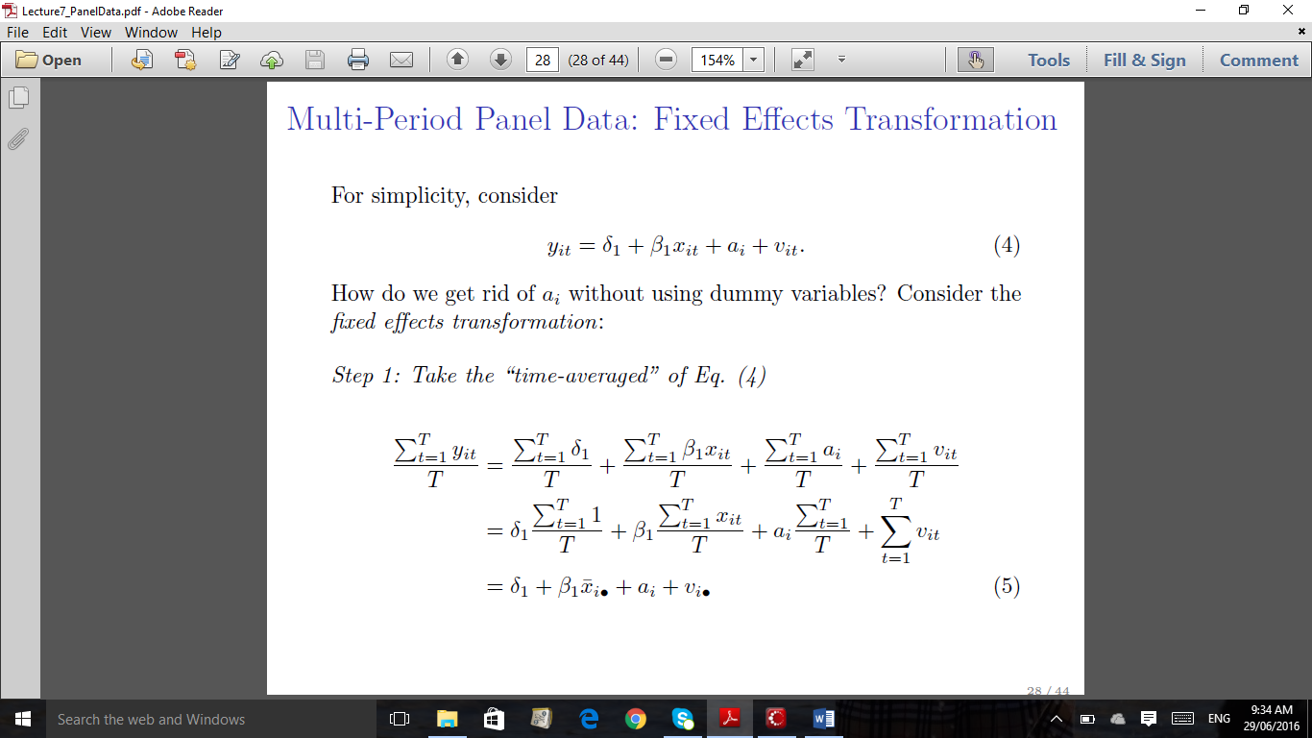..... (3)

where:
y_{it} = the dependent variable,
x′_{it} = K-dimensional row vector of time-varying explanatory variables
z′_{I} = M-dimensional row vector of time-invariant explanatory variables excluding the constant,
α = the intercept,
β = K-dimensional column vector of parameters,
γ = M-dimensional column vector of parameters,
c_{i} = an individual specific effect and
u_{it} = the error term

Fixed Effects Model

The fixed effects method controls for time-invariant variables that have not been measured but that affect y. For example, it could control for the effect of race if information on race was not available in the data set. However, while the effects of time-invariant variables (measured or unmeasured) can be controlled for, their effects cannot actually be estimated, i.e. we cannot estimate the γ for the model.

On the other hand, if α is uncorrelated with the xs (e.g. because no time-invariant variables are omitted, or because the variables that are omitted are not correlated with the variables that are in the model) then a random effects model can provide unbiased estimates of both the β and the γ, and will generally have lower standard errors than a fixed effects model.
In experimental research, unmeasured differences between subjects are often controlled for via random assignment to treatment and control groups. Hence, even if a variable like Socio-Economic Status is not explicitly measured, because of random assignment, we can be reasonably confident that the effects of SES are approximately equal for all groups. Of course, random assignment is usually not possible with most survey research. If we want to control for the effect of a variable, we must explicitly measure it. If we don’t measure it, we can’t control for it. In practice, there will almost certainly be some variables we have failed to measure (or have measured poorly), so our models will likely suffer from some degree of omitted variable bias.

RESULT

Oil fuel price development in Indonesia
During April 1979 to June 2013, the trend of price of gasoline and diesel show the increase. The price of diesel increased 32.44 % average per year from IDR. 35/litre in 1979 to become IDR.5,500 /litre in 2013. Similarly, the price of gasoline increased 26.10 % average per year from IDR. 100/litre to become IDR.6,500 / litre. Like shown by Figure 1 below.

Figure 1. The Oil Price Development in Indonesia, 1979 – 2013
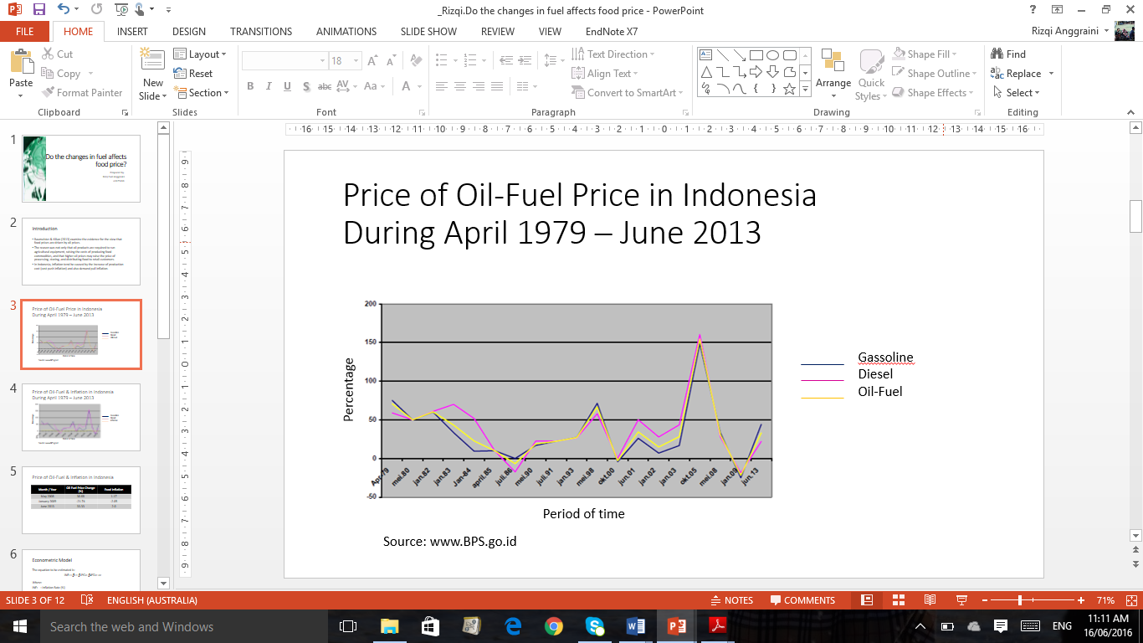
Source: www.BPS.go.id

Inflation rate development in Indonesia

Inflation is the rate of increase in prices over a given period of time. Inflation is typically a broad measure, such as the overall increase in prices or the increase in the cost of living in a country. But it can also be more narrowly calculated—for certain goods, such as food, or for services. Inflation represents how much more expensive the relevant set of goods and/or services has become over a certain period, most commonly a year.
The inflation rate is measured by using the consumer price index (CPI). CPI is the average consumer’s cost living. To measure the average consumer’s cost of living, government agencies conduct household surveys to identify a basket of commonly purchased items and track over time the cost of purchasing this basket (food stuff, processed food, housing expenses, including rent and mortgages, clothing, health, education recreation and sports, transportation and communication constitute the largest component of the consumer basket in Indonesia.) The cost of this basket at a given time expressed relative to a base year is the consumer price index (CPI), and the percentage change in the CPI over a certain period is consumer price inflation, the most widely used measure of inflation. (For example, if the base year CPI is 100 and the current CPI is 110, inflation is 10 percent over the period) (Basic,2016).
The inflation rate development in Indonesia can be shown by Figure 2. In April 1979 to January 1984, the monthly inflation rate were over 3 %. The trend tend to declined, except in May 1998 and October 2005, it reached its peak on 8.7 %. Based on, yearly inflation, the inflation rate in 1998 had been the highest inflation rate ever in Indonesia.

Figure 2. Inflation rate development in Indonesia, 1979-2013

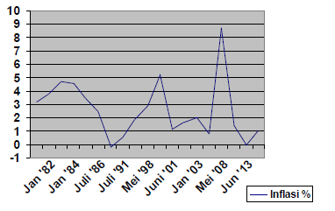
Source: www.BPS.go.id
The correlation between oil fuel price change and food inflation rate in Indonesia

During the period 1979 to 2013 the inflation rate in Indonesia tend to be decreased. It seems correlate to fuel price (diesel and gasoline). However, inflation rate rise to point 3.2 % in 1979 when government rise the fuel price, however the inflation rate only increase 1.03 % in 2013 at the same regulation. The inflation rate relative to fuel price can be shown from Figure 3 below.

Figure 3. The Oil Price Development and food inflation rate in Indonesia in Indonesia, 1979 – 2013.
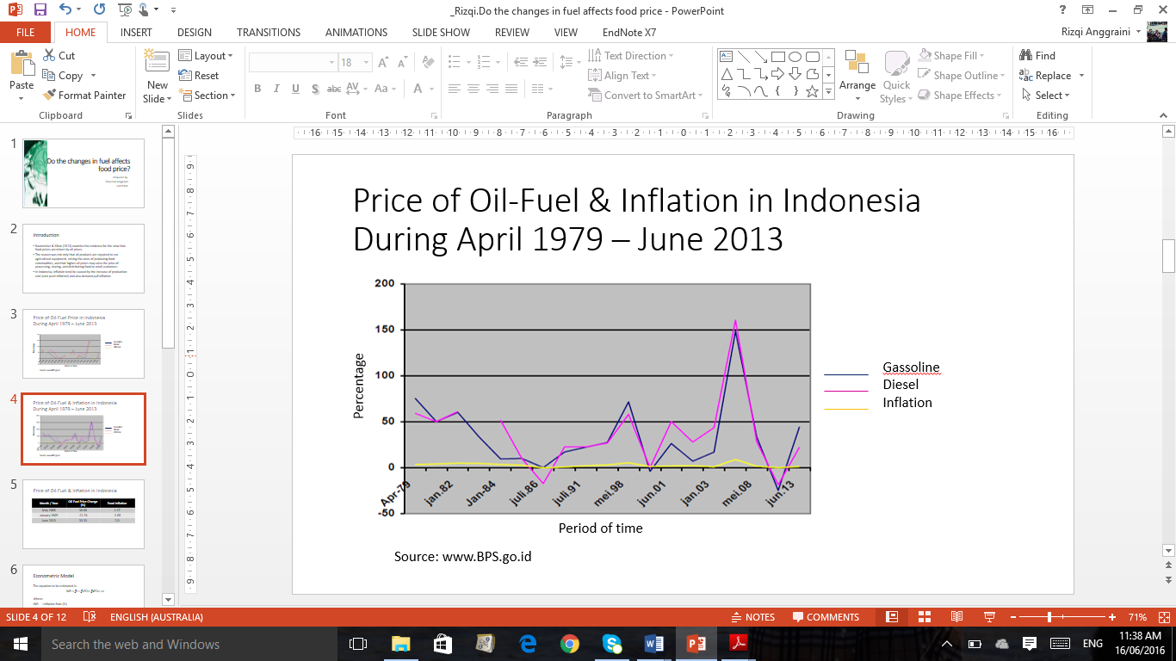

Source: www.BPS.go.id

As shown by Figure 2, the inflation rate in Indonesia tend to be fluctuated with the trend that is almost same with fuel price trend.

Table 1. The Oil Fuel Price Change and Food Inflation

Month/Year | Oil Fuel Changed Price (%) | Food inflation (%)
May 2008 | 30.68 | 1.17
January 2009 | -21.74 | -2.05
June 2013 | 33.33 | 2.0
Source: www.BPS.go.id

Fixed-effect regression result between oil fuel price change and food inflation rate

The result of regression analysis utilizing yearly data from January 2013 to December 2015, reveal the following relationship:
IHK = 344.76 – 0.0066GASSPRICE – 0.023DIESELPRICE
The effect of gasoline and diesel price change significantly correlate to inflation in Indonesia. It can be seen from R² 0.88, means 88 % fluctuation in inflation rate are determined by oil-fuel price. However, beside multi-co linearity between two independent variables issue. The regression result shows that effect of gasoline price change to inflation is 0.0066. It means, if there is 1 % of increase at gasoline price will lower inflation 0.0066 %. Logically, this is not true. According to Sim (2016) this strange result is likely to be due to omitted variable problems.
Sim (2016) also suggests, one solution to view the unobserved factors (i.e. the error term) affecting the dependent variable as consisting of two components: those that are time-invariant (a_{i}) and those that vary over time (v_{it}) and attribute the problem to a_{i}. A simple unobserved effects model for inflation rates for 2013 and 2015 is:

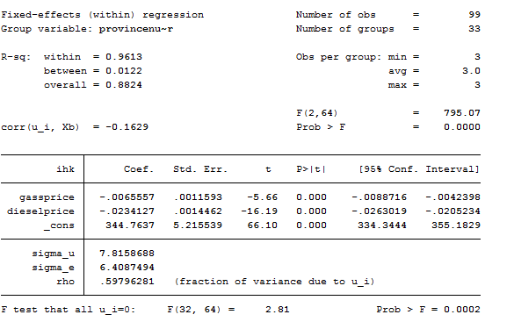
INF _{it} = δ₁ + δ₂d2013_{t} +β₁gass_{it} + β₂ diesel _{it} + a_{i} + v_{it}
where:
d2013 is a dummy variable for 2013
a_{i} is province fixed effect

CONCLUSION AND RECOMMENDATION

Conclusion
- Food insecurity exists when people do not have adequate physical, social or economic access to food as defined above.
- Shocks like droughts or economic downturns can affect individuals who normally have appropriate access to food, threatening the stability of food security which implies adequate access to food at all times.
- The inflation rate in Indonesia tend to be fluctuated with the trend that is almost same with fuel price trend.
- The effect of gasoline and diesel price change significantly correlate to inflation in Indonesia. It can be seen from R² 0.88, means 88 % fluctuation in inflation rate are determined by oil-fuel price. However, the model gives the strange result. Therefore, it cannot be used to estimate the correlation between oil-fuel price-changed to inflation rate in Indonesia.

Recommendation

- It is needed to find out one solution to view the unobserved factors (i.e. the error term) affecting the dependent variable as consisting of two components: those that are time-invariant (a_{i}) and those that vary over time (v_{it}) and attribute the problem to a_{i}.

REFERENCES

Baumeister, C and L Kilian (2013), “Do Oil Price Increases Cause Higher Food Prices?”, CEPR Discussion Paper 9689.

Cuesta, J, Htenas A, & Tiwari, S 2014, ‘Monitoring Global and National Food Price Crises’, Food Policy, vol. 10, no.49, pp. 84-94.
FAO (2003), ¹http://www.fao.org/hunger/en/
Indonesia Central Bureau of Statistics. http://www.bps.go.id
Iman, P (2011), “Food Price Rises Pushing Millions into Extreme Poverty, World Bank Warns”,Guardian, 14 April.
Ivanic, M and W Martin (2008), “Implications of Higher Global Food Prices for Poverty in Low-Income Countries”, World Bank Policy Research Working Paper 4594.
Kilian, L and D P Murphy (2013), “The Role of Inventories and Speculative Trading in the Global Market for Crude Oil”, Journal of Applied Econometrics, forthcoming.
Rosegrant, M W (2008), “Biofuels and Grain Prices: Impacts and Policy Responses”, Testimony for the US Senate Committee on Homeland Security and Governmental Affairs, 7 May.
Sim, N (2016), “Panel Data”, Lecture Note School of Economics University of Adelaide.

Appendix
Province Name | Province Number | Year | IHK  CPI  (Costumer Price Index) | Price of Retail Gassoline (IDR) | Price of Retail Diesel (IDR)
Province Name | i | t | Y | X1 | X2
Aceh | 1 | 2013 | 148.33 | 6,183 | 5,500
Aceh | 1 | 2014 | 114.52 | 8,127 | 7,500
Aceh | 1 | 2015 | 121.49 | 8,791 | 6,900
North Sumatra | 2 | 2013 | 160.55 | 5,886 | 5,500
North Sumatra | 2 | 2014 | 117.44 | 7,903 | 7,500
North Sumatra | 2 | 2015 | 124.45 | 8,358 | 6,900
West Sumatra | 3 | 2013 | 177.75 | 6,280 | 5,500
West Sumatra | 3 | 2014 | 115.89 | 7,904 | 7,500
West Sumatra | 3 | 2015 | 131.13 | 8,506 | 6,900
Riau | 4 | 2013 | 162.31 | 6,490 | 5,500
Riau | 4 | 2014 | 115.97 | 8,217 | 7,500
Riau | 4 | 2015 | 123.98 | 8,834 | 6,900
Jambi | 5 | 2013 | 167.67 | 6,898 | 5,500
Jambi | 5 | 2014 | 116.43 | 8,722 | 7,500
Jambi | 5 | 2015 | 118.07 | 9,285 | 6,900
South Sumatra | 6 | 2013 | 170.66 | 6,662 | 5,500
South Sumatra | 6 | 2014 | 112.07 | 7,654 | 7,500
South Sumatra | 6 | 2015 | 118.34 | 8,125 | 6,900
Bengkulu | 7 | 2013 | 183.76 | 6,563 | 5,500
Bengkulu | 7 | 2014 | 123.35 | 8,449 | 7,500
Bengkulu | 7 | 2015 | 134.31 | 9,060 | 6,900
Lampung | 8 | 2013 | 177.89 | 6,427 | 5,500
Lampung | 8 | 2014 | 118.26 | 8,101 | 7,500
Lampung | 8 | 2015 | 130.63 | 8,795 | 6,900
Bangka Belitung Island | 9 | 2013 | 173.28 | 6,450 | 5,500
Bangka Belitung Island | 9 | 2014 | 114.00 | 8,433 | 7,500
Bangka Belitung Island | 9 | 2015 | 120.36 | 8,996 | 6,900
Riau Island | 10 | 2013 | 171.76 | 6,063 | 5,500
Riau Island | 10 | 2014 | 120.61 | 7,558 | 7,500
Riau Island | 10 | 2015 | 128.10 | 8,122 | 6,900
Jakarta | 11 | 2013 | 182.42 | 6,361 | 5,500
Jakarta | 11 | 2014 | 123.81 | 7,251 | 7,500
Jakarta | 11 | 2015 | 133.17 | 7,688 | 6,900
West Java | 12 | 2013 | 166.25 | 5,387 | 5,500
West Java | 12 | 2014 | 118.95 | 7,322 | 7,500
West Java | 12 | 2015 | 128.84 | 7,813 | 6,900
Central Java | 13 | 2013 | 168.28 | 5,346 | 5,500
Central Java | 13 | 2014 | 119.40 | 7,428 | 7,500
Central Java | 13 | 2015 | 129.17 | 7,937 | 6,900
Yogyakarta | 14 | 2013 | 183.62 | 5,307 | 5,500
Yogyakarta | 14 | 2014 | 121.47 | 7,257 | 7,500
Yogyakarta | 14 | 2015 | 128.45 | 7,682 | 6,900
East Java | 15 | 2013 | 180.40 | 5,369 | 5,500
East Java | 15 | 2014 | 118.75 | 7,385 | 7,500
East Java | 15 | 2015 | 126.48 | 7,906 | 6,900
Banten | 16 | 2013 | 173.96 | 5,488 | 5,500
Banten | 16 | 2014 | 123.13 | 7,264 | 7,500
Banten | 16 | 2015 | 134.57 | 7,782 | 6,900
Bali | 17 | 2013 | 187.53 | 5,366 | 5,500
Bali | 17 | 2014 | 116.77 | 7,469 | 7,500
Bali | 17 | 2015 | 126.49 | 7,644 | 6,900
West Nusa Tenggara | 18 | 2013 | 191.05 | 5,649 | 5,500
West Nusa Tenggara | 18 | 2014 | 118.51 | 7,519 | 7,500
West Nusa Tenggara | 18 | 2015 | 123.62 | 8,067 | 6,900
East Nusa Tenggara | 19 | 2013 | 167.65 | 6,293 | 5,500
East Nusa Tenggara | 19 | 2014 | 108.39 | 8,564 | 7,500
East Nusa Tenggara | 19 | 2015 | 114.67 | 9,345 | 6,900
West Kalimantan | 20 | 2013 | 185.35 | 8,617 | 5,500
West Kalimantan | 20 | 2014 | 117.39 | 10,887 | 7,500
West Kalimantan | 20 | 2015 | 129.98 | 11,605 | 6,900
Central Kalimantan | 21 | 2013 | 192.55 | 6,321 | 5,500
Central Kalimantan | 21 | 2014 | 114.67 | 7,951 | 7,500
Central Kalimantan | 21 | 2015 | 122.10 | 8,770 | 6,900
South Kalimantan | 22 | 2013 | 182.79 | 6,389 | 5,500
South Kalimantan | 22 | 2014 | 117.35 | 8,209 | 7,500
South Kalimantan | 22 | 2015 | 125.36 | 8,910 | 6,900
East Kalimantan | 23 | 2013 | 187.81 | 6,592 | 5,500
East Kalimantan | 23 | 2014 | 116.79 | 8,110 | 7,500
East Kalimantan | 23 | 2015 | 123.46 | 8,827 | 6,900
North Sulawesi | 24 | 2013 | 182.57 | 6,534 | 5,500
North Sulawesi | 24 | 2014 | 117.70 | 8,590 | 7,500
North Sulawesi | 24 | 2015 | 132.23 | 9,077 | 6,900
Central Sulawesi | 25 | 2013 | 171.29 | 6,304 | 5,500
Central Sulawesi | 25 | 2014 | 114.57 | 7,773 | 7,500
Central Sulawesi | 25 | 2015 | 120.33 | 8,625 | 6,900
South Sulawesi | 26 | 2013 | 171.48 | 5,709 | 5,500
South Sulawesi | 26 | 2014 | 113.43 | 7,480 | 7,500
South Sulawesi | 26 | 2015 | 130.33 | 8,243 | 6,900
South East Sulawesi | 27 | 2013 | 183.76 | 6,695 | 5,500
South East Sulawesi | 27 | 2014 | 107.89 | 8,506 | 7,500
South East Sulawesi | 27 | 2015 | 116.60 | 9,135 | 6,900
Gorontalo | 28 | 2013 | 163.02 | 5,697 | 5,500
Gorontalo | 28 | 2014 | 106.36 | 7,323 | 7,500
Gorontalo | 28 | 2015 | 111.81 | 7,896 | 6,900
West Sulawesi | 29 | 2013 | 170.42 | 5,861 | 5,500
West Sulawesi | 29 | 2014 | 109.32 | 7,369 | 7,500
West Sulawesi | 29 | 2015 | 120.43 | 8,027 | 6,900
Maluku | 30 | 2013 | 181.27 | 7,831 | 5,500
Maluku | 30 | 2014 | 117.72 | 10,087 | 7,500
Maluku | 30 | 2015 | 129.32 | 10,730 | 6,900
North Maluku | 31 | 2013 | 170.14 | 7,658 | 5,500
North Maluku | 31 | 2014 | 110.86 | 9,585 | 7,500
North Maluku | 31 | 2015 | 119.63 | 10,144 | 6,900
West Papua | 32 | 2013 | 167.17 | 6,656 | 5,500
West Papua | 32 | 2014 | 111.74 | 8,716 | 7,500
West Papua | 32 | 2015 | 114.59 | 9,358 | 6,900
Papua | 33 | 2013 | 154.69 | 8,581 | 5,500
Papua | 33 | 2014 | 116.84 | 10,928 | 7,500
Papua | 33 | 2015 | 126.67 | 11,915 | 6,900
Source: Indonesia Central Bureau of Statistics. http://www.bps.go.id

